软件学院 级软件工程专业(2012-1)
《软件测试》期末试题试卷(A)
(考试形式：闭卷 考试时间: 2小时)
警 示
《中山大学授予学士学位工作细则》第六条
考试作弊不授予学士学位

方向：___________ 姓名： ______ 学号： 成绩：____________

注意：答案一定要写在答卷中，写在本试题卷中不给分。答题时注明各题题号，并在答题
纸上写上姓名和学号。本试卷要和答卷一起交回。

一、选择题（每题3分）
1. How many statements are true?
(1) You can perform dynamic black-box testing without a product specification or requirements document.
(2) If your product development is in a hurry, you can skip module testing and proceed directly to integration testing.
(3) Threat modeling is an informal process done by the software testers to decide where best to apply their tests for security vulnerabilities.
Answers: A) 0 B) 1 C) 2 D) 3

2. How many statements are true?
(1) Regression tests show if all defects have been resolved.
(2) Regression tests are typically well-suited for test automation.
(3) Regression tests should be performed in integration testing.
Answers: A) 0 B) 1 C) 2 D) 3

3. How many statements are true?
(1) All software has a user interface and therefore must be tested for usability.
(2) Compatibility is a product feature and can have different levels of compliance.
(3) Always design your black-box test cases first.
Answers: A) 0 B) 1 C) 2 D) 3

4. How many statements are true?
(1) With the big-bang model of software development, we have lower cost of testing.
(2) An invasive(侵入性) tool is the best type because it operates closest to the software being tested.
(3) A good tester relentlessly strives(坚持不懈地追求) for perfection.
Answers: A) 0 B) 1 C) 2 D) 3

5. How many statements are true?
(1) Software testing is mainly needed to improve the quality of the developer’s work.
(2) Rigorous testing and fixing of defects found can help reduce the risk of problems occurring in an operational environment.
(3) Rigorous testing is sometimes used to prove that all failures have been found.
Answers: A) 0 B) 1 C) 2 D) 3

6. Which statement below BEST describes non-functional testing?
A) The process of testing an integrated system to verify that it meets specified requirements.
B) The process of testing to determine the compliance of a system to coding standards.
C) Testing without reference to the internal structure of a system
D) Testing system attributes, such as usability, reliability or maintainability.

7. Which one of the review types below are the BEST fitted (most adequate) options to review source code.
A) Formal review
B) Inspection
C) Peer review
D) Technical Review

8. One of the test goals for the project is to have 100% decision coverage. The following three test cases have been executed for the control flow graph shown below.
Test case 1 covers path: A, B, D, E, G.
Test case 2 covers path: A, B, D, E, F, G.
Test case 3 covers path: A, C, F, C, F, C, F, G.
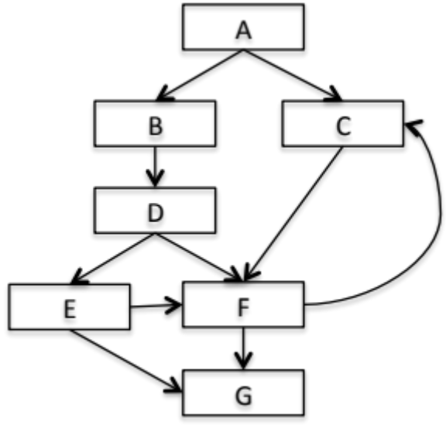
Which of the following statements related to the decision coverage goal is correct?
A) Decision D has not been tested completely.
B) 100% decision coverage has been achieved.
C) Decision E has not been tested completely.
D) Decision F has not been tested completely.

9. An employee’s bonus is to be calculated. It cannot become negative, but it can be calculated to zero. The bonus is based on the duration of the employment. An employee can be employed for less than or equal to 2 years, more than 2 years but less than 5 years, 5 to 10 years, or longer than 10 years. Depending on this period of employment, an employee will get eitherno bonus or a bonus of 10%, 25% or 35%.
How many equivalence partitions are needed to test the calculation of the bonus?
A) 3 B) 5 C) 2 D) 4

10. Which one of the following techniques is structure-based?
A) Decision testing (Logical Coverage).
B) Boundary value analysis.
C) Equivalence partitioning.
D) State transition testing.

二、简答题（每题6分）
1. Why would a software tester like the spiral or iterative model better than the others?
2. Why is it impossible to test a program completely?
3. Explain what's wrong with this specification statement: When the user selects the Compact Memory option, the program will compress the mailing list data as small as possible using a Huffman-sparse-matrix approach.
4、 If you're testing a program's ability to print to a printer, what generic test-to-fail test cases might be appropriate?
5、 What are the three basic states of a software bug's life cycle and the two common additional states?
三、应用题（每题20分）
1、 White-box
(1) Give a flow chart for the following source code.
(2) Analyze the basis path for the flow chart, and list the basis test paths.
(3) Design a suite of test cases to coverage all these paths.

Program list: binary search - c (simple)
1. /**
2. #include <stdio.h>
3. /**
4. * binary search (simple)
5. *
6. * @param
7. * arr pointer of array
8. * @param
9. * len length of array
10. * @param
11. * x target to search
12. *
13. * @return
14. index of target in the array,return -1 if not found,
15. */
16. int bin_search(int *arr,int len,int x) {
17. // indexs
18. int start = 0,end = len-1,middle;
19. while (end >= start) {
20. middle = (start + end) >> 1;
21. if (*(arr+middle)==x) {
22. return middle;
23. } else if(x < *(arr+middle)) {
24. end = middle - 1;
25. } else {
26. start = middle + 1;
27. }
28. }
29. // not found
30. return -1;
31. }

2、 Black-box
Design functional test cases for the following QQ login form.
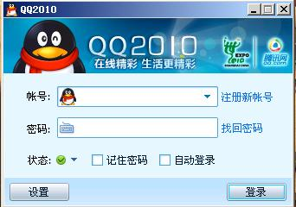

（1）Design the effective and efficiency test cases.
（2）Explain the reasons why we select these test cases.

